# 1.Customer Part

## 1-1.Home Page

This is first page.

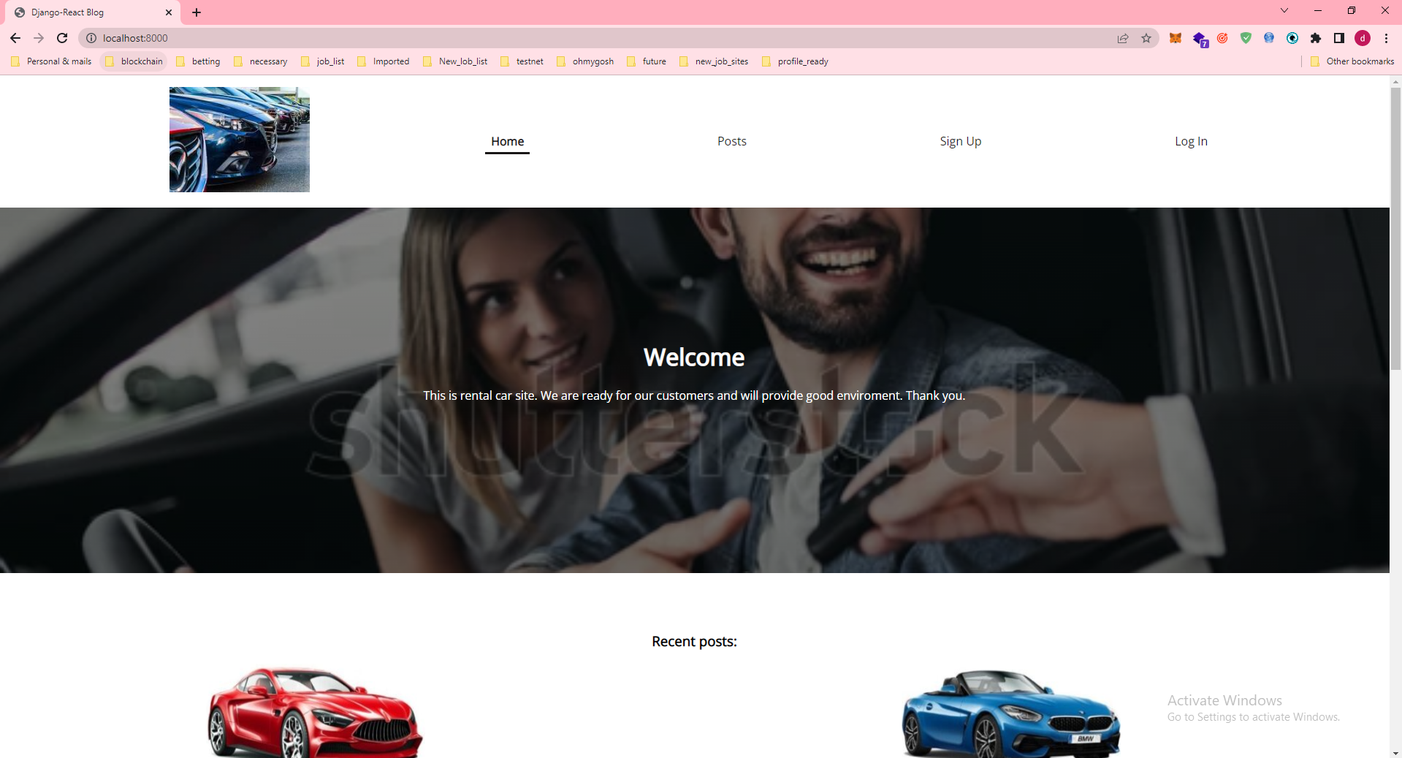

## 1-2.Posts Page

### Post List page

They show Rent-Car-list.

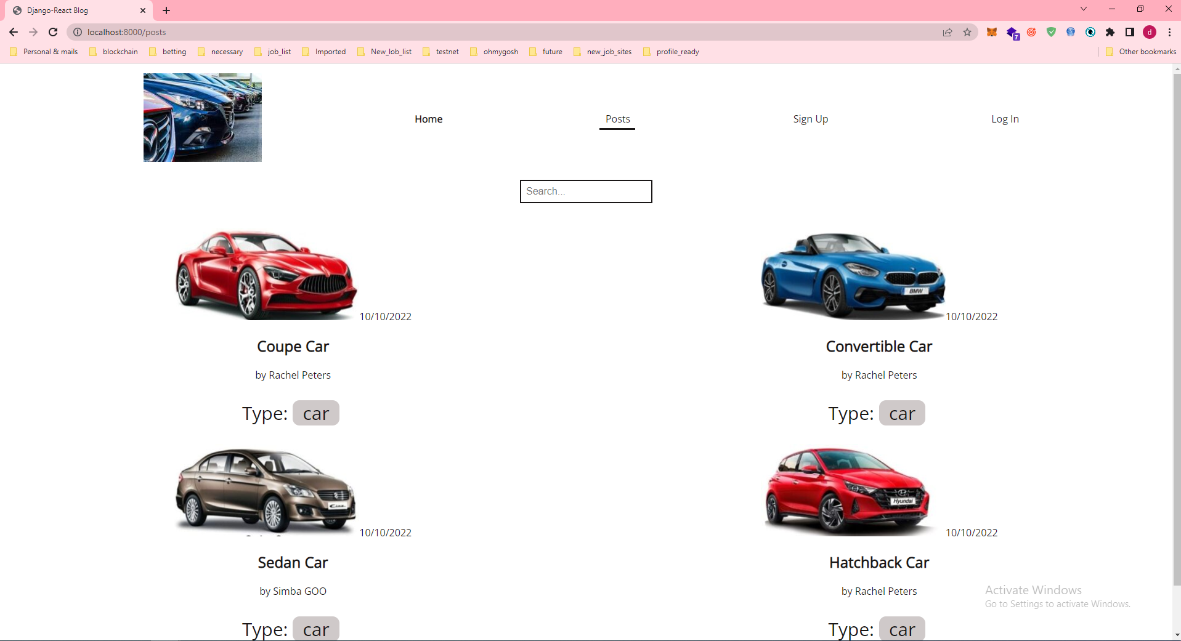

### 2)Post Car

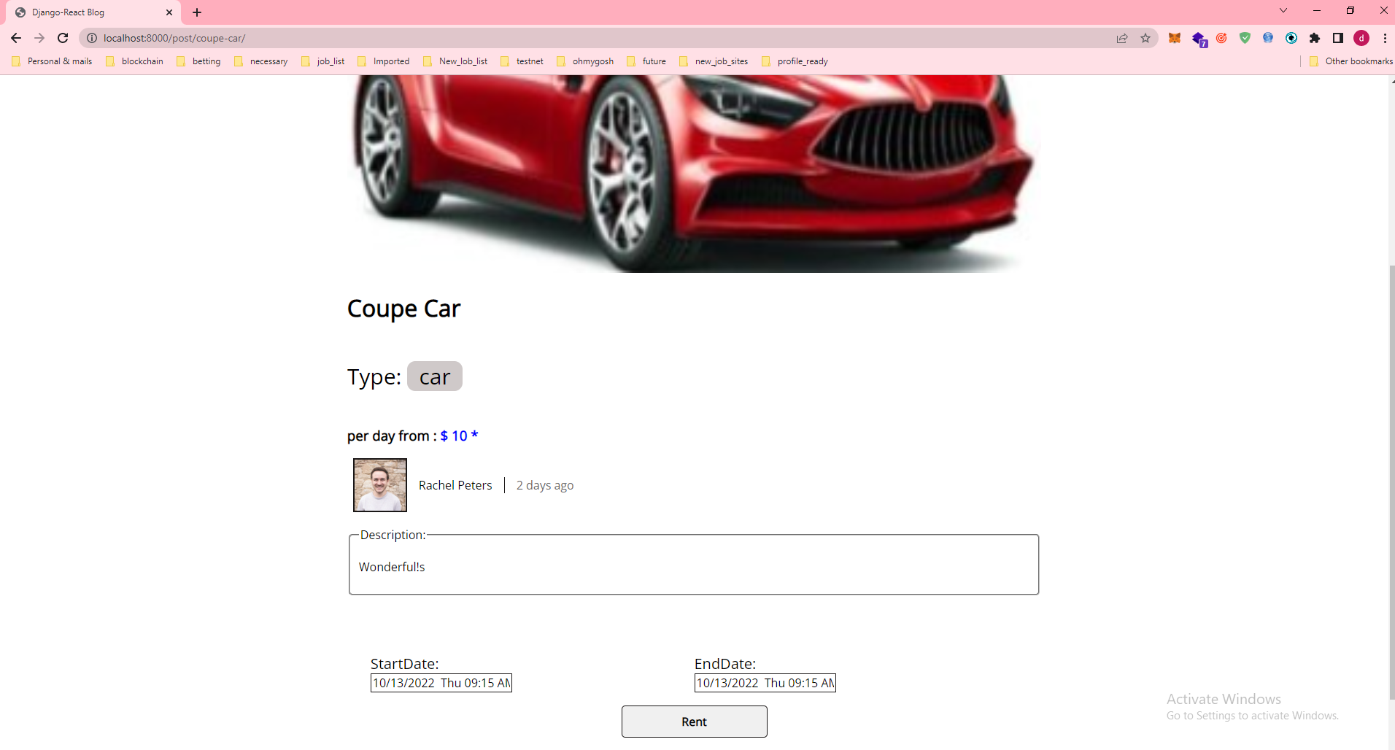

We can see it after you clicked any car on Post List Page

So we can see “StartDate” and “EndDate” and then we can determine using days.

As you know, we should determine correctly between start Date and end date.

If you click Button with name “Rent”, we can lend car.

And so that car’s available state is ‘false’ and then we can’t find that car on Post List page.

Because it checked.

## 1-3.Sign Up

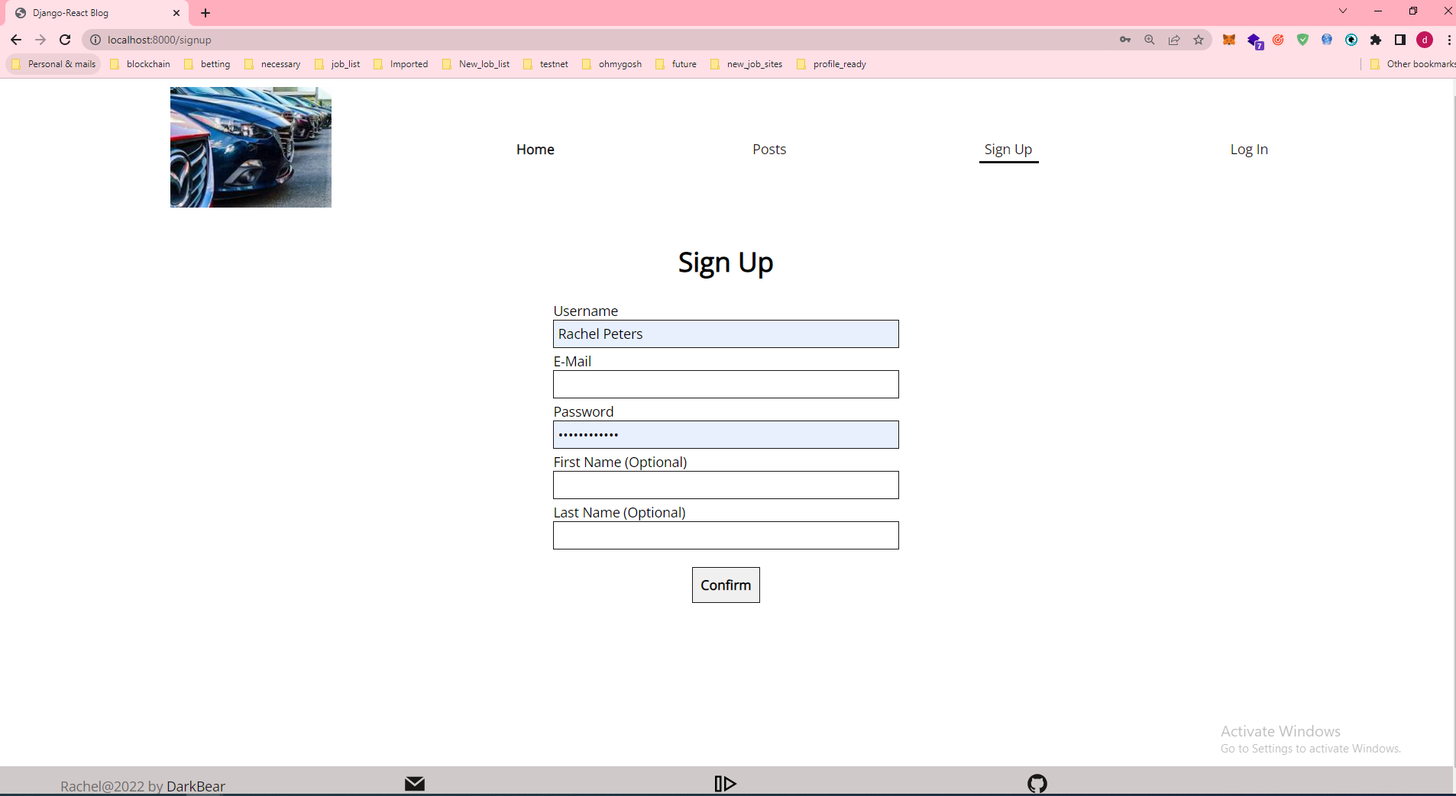

## 1-4.Log In

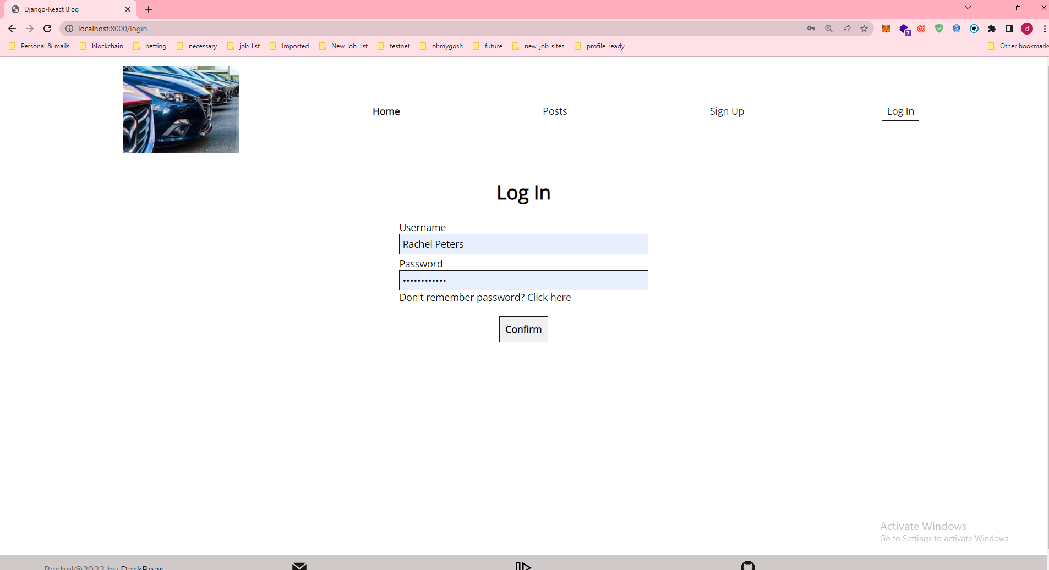

## 1-5 User Panel

### 1)Personal Inforamtion

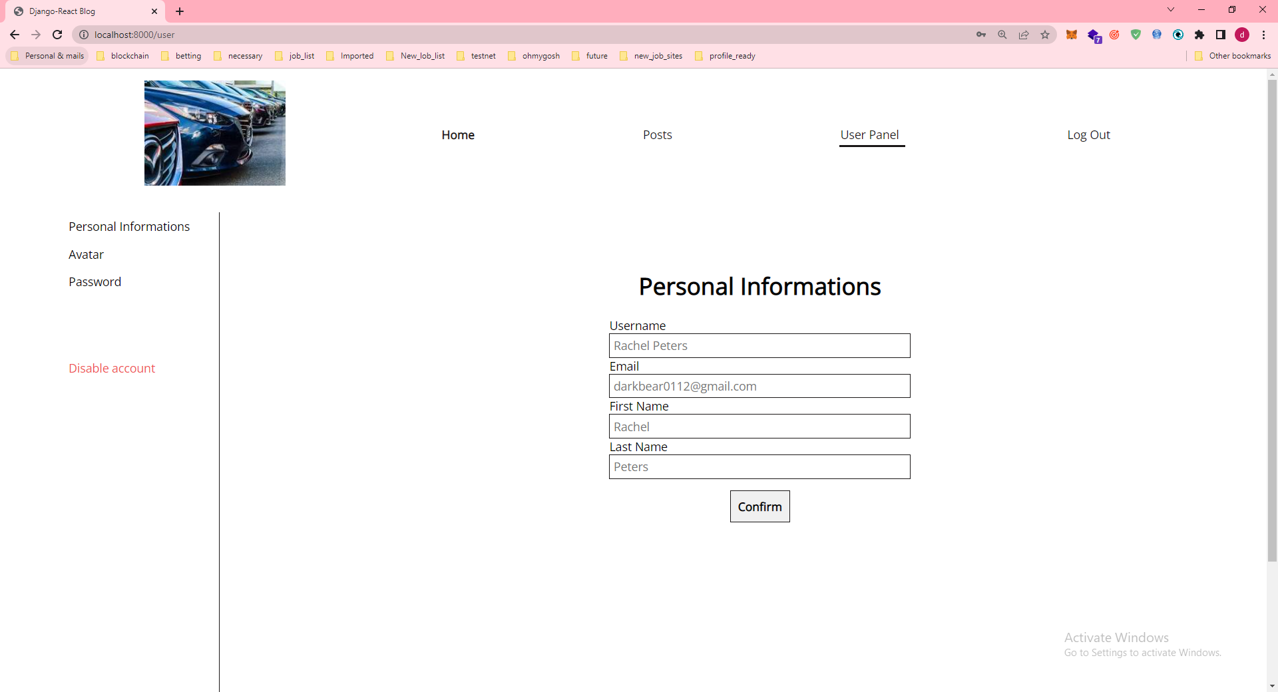

### Change User’s avatar

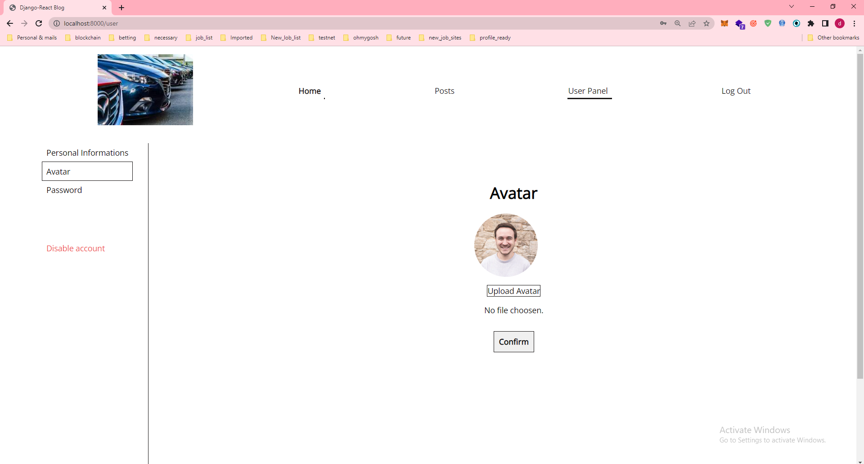

### change Password

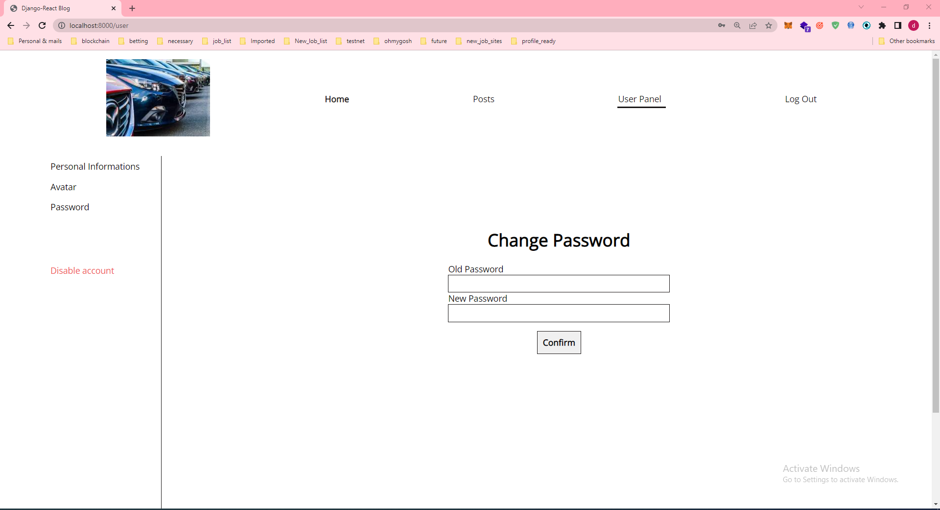

# 2)Admin Panel

## 2-1 Admin Dashboard

They show all function list.

Posts (Rent car list) , Tags(Types of Car) , Tokens, Users

And then Recent actions page too.

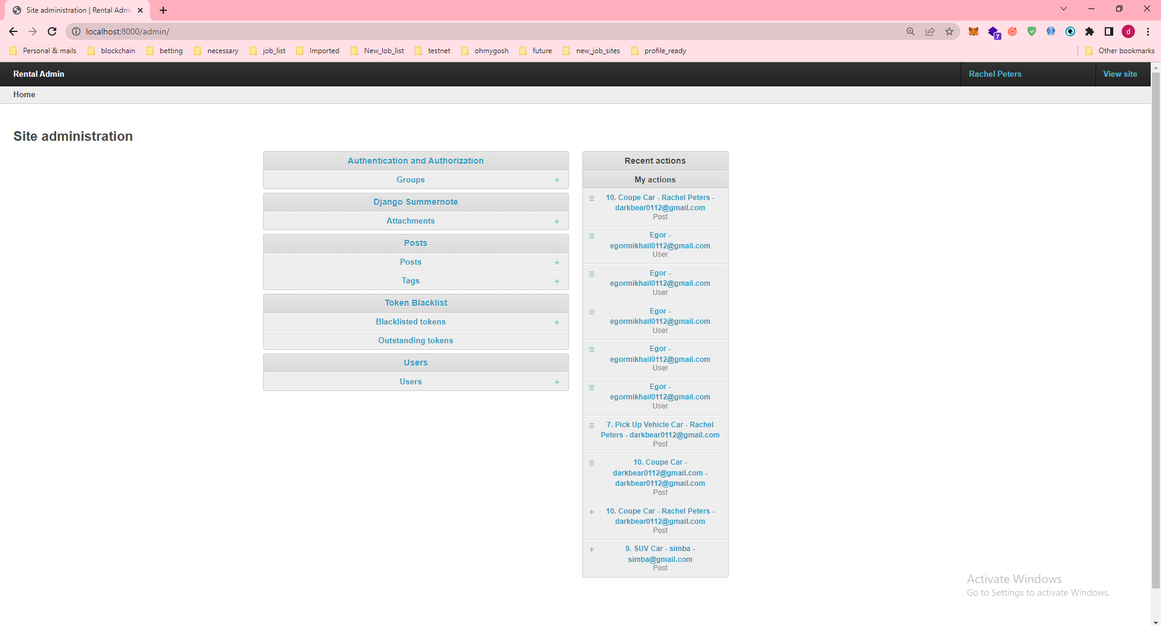

## 2-2 Post Part

### 1)Post List Page

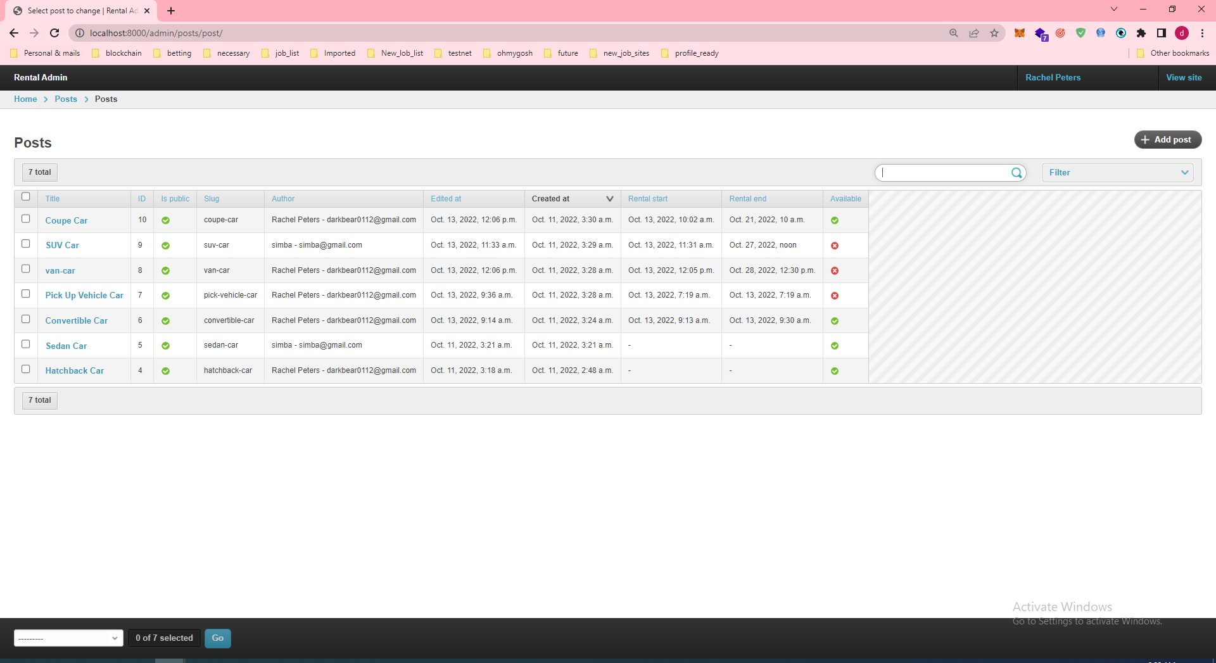

We can see all post’s information.

And please focus on right part.

So we can see Filter part.

At there , we can filter available(it is possible to lend car?) , rental start and rental end date and public.

A variable with named ‘Is public’ mean that it is public or unpublic.

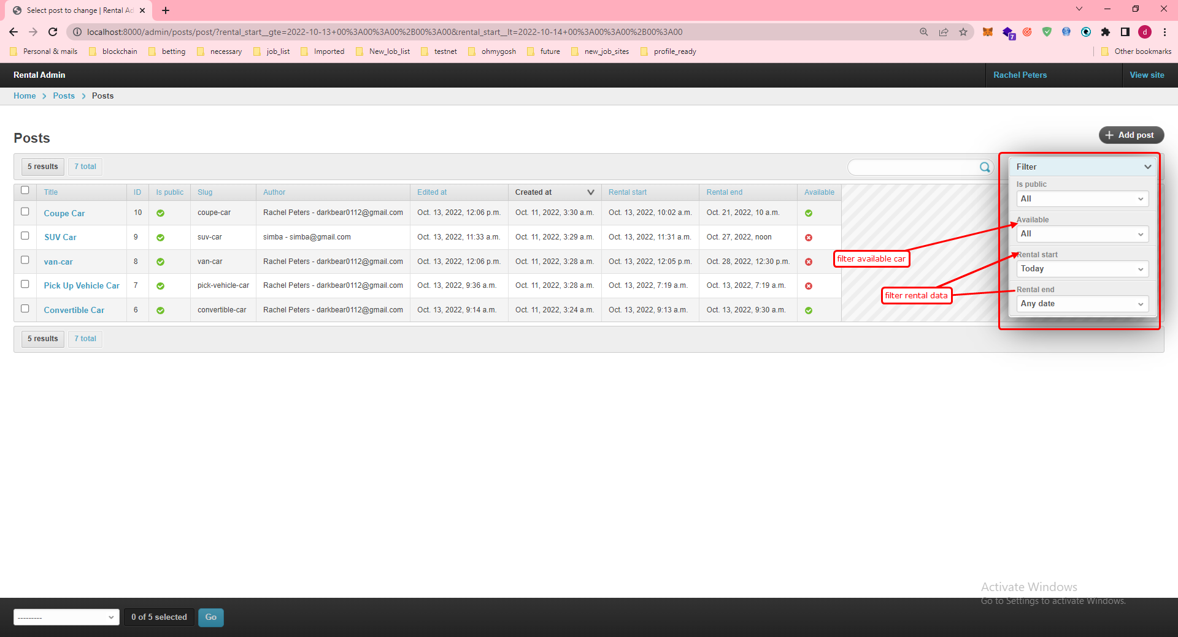

And finally please focus on bottom part.

So we can set multi setting

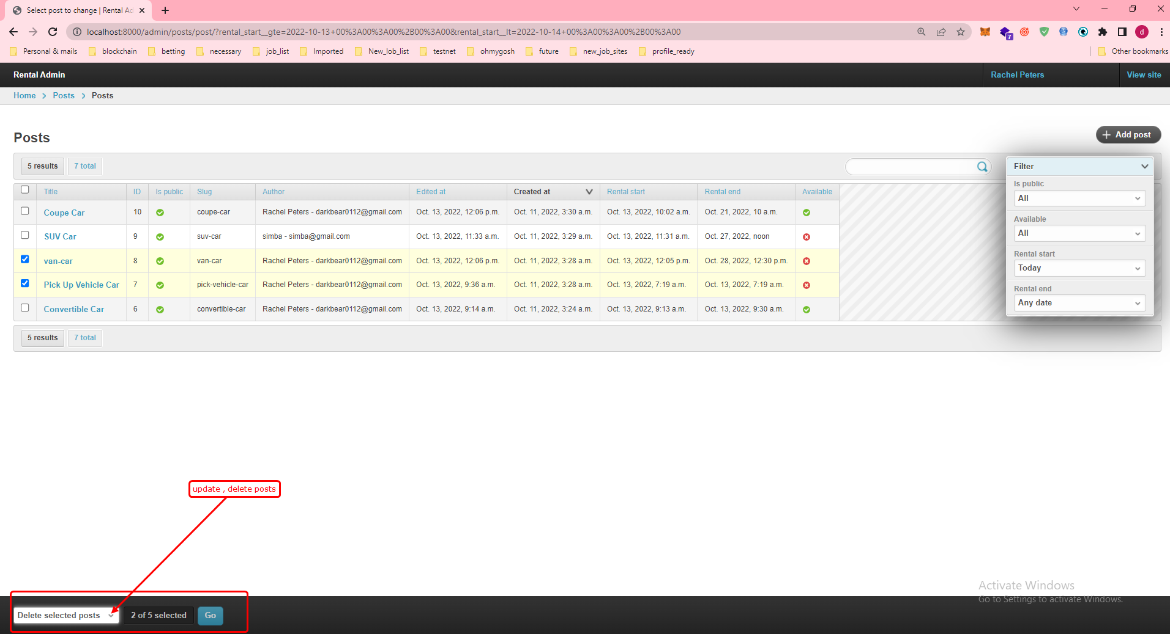

### 2)Post Edit page

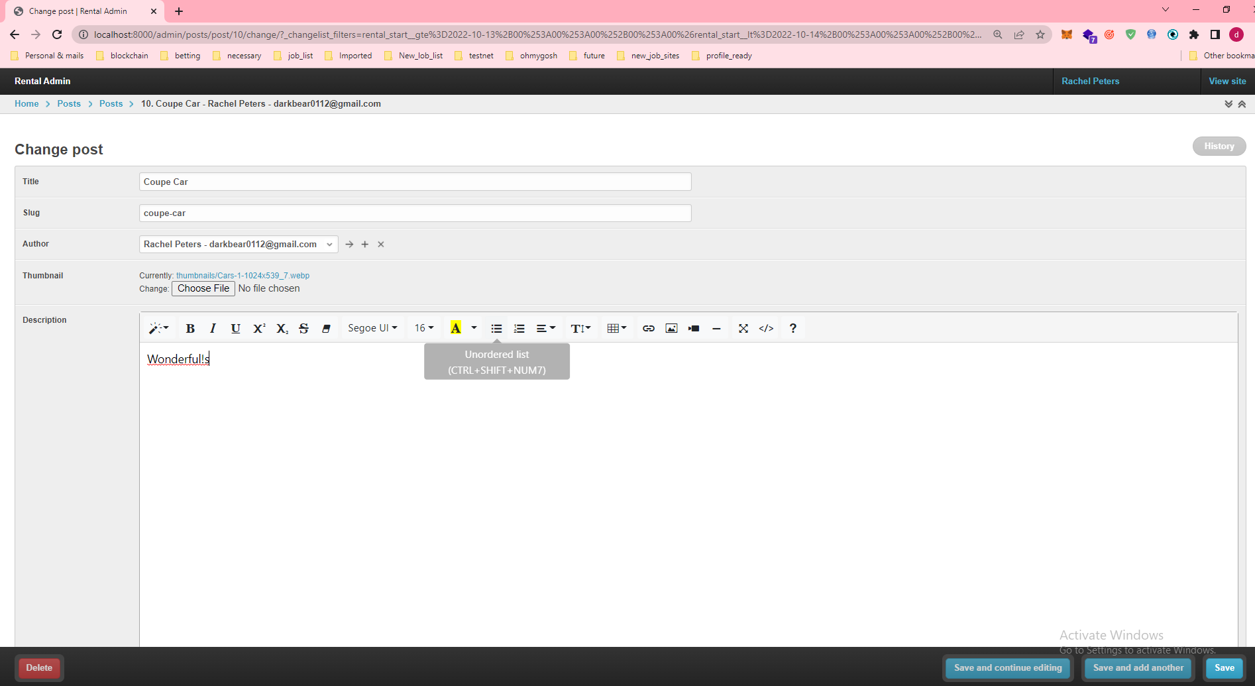

## 2-3User

### UserList

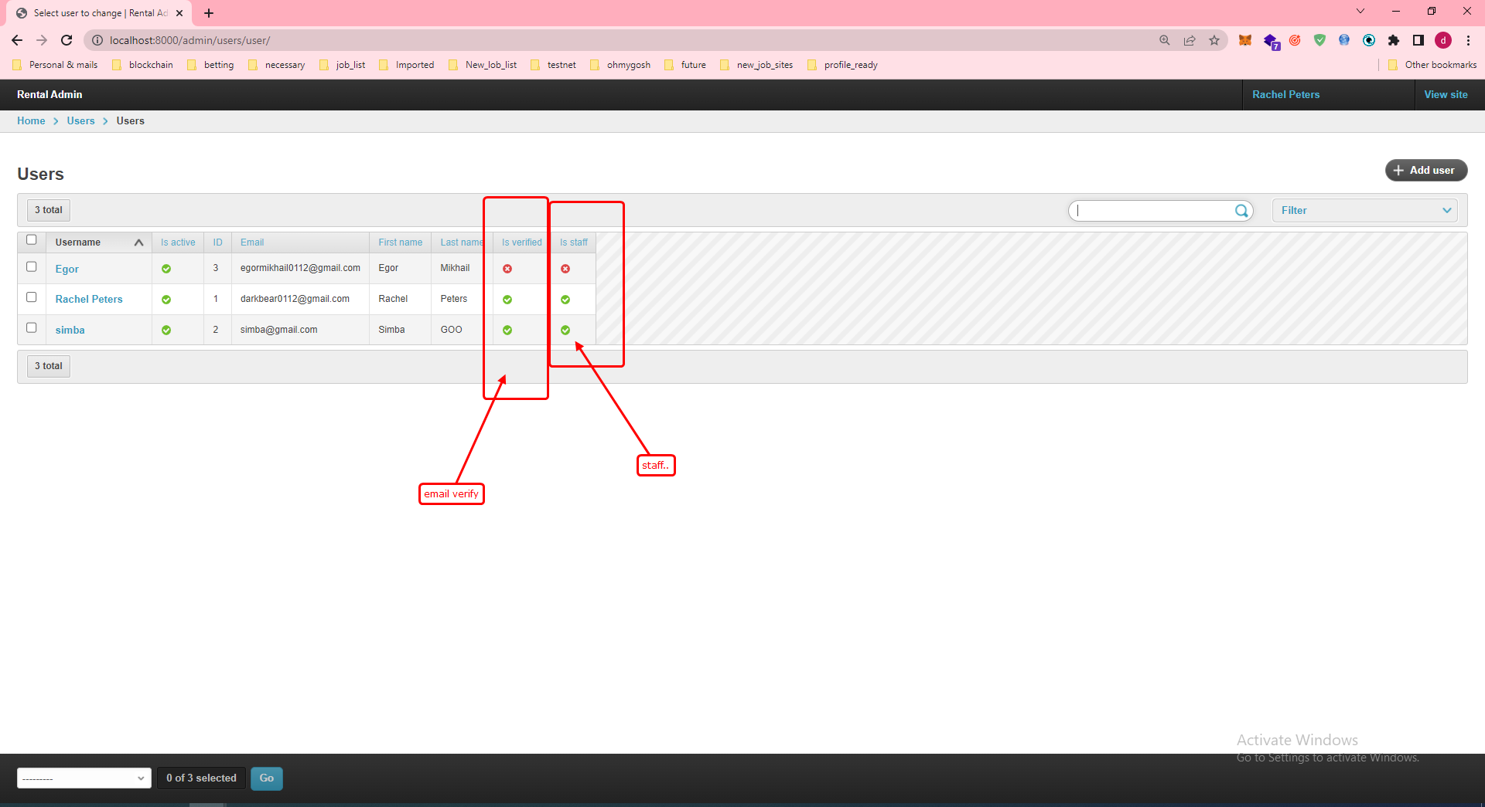

### User

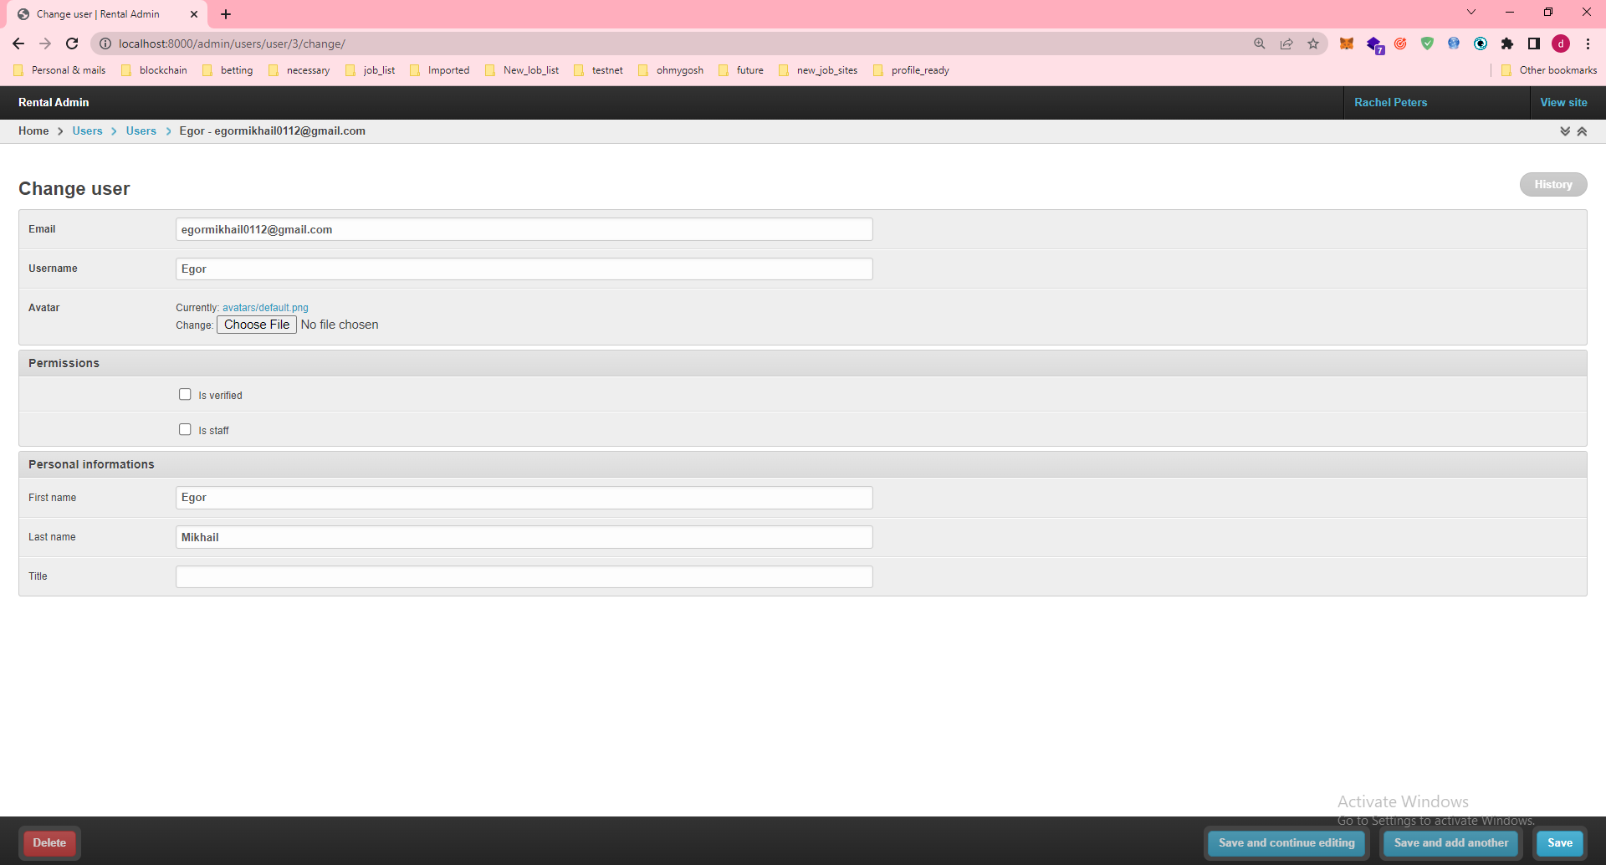

## 2-4 Tags(Car Types)

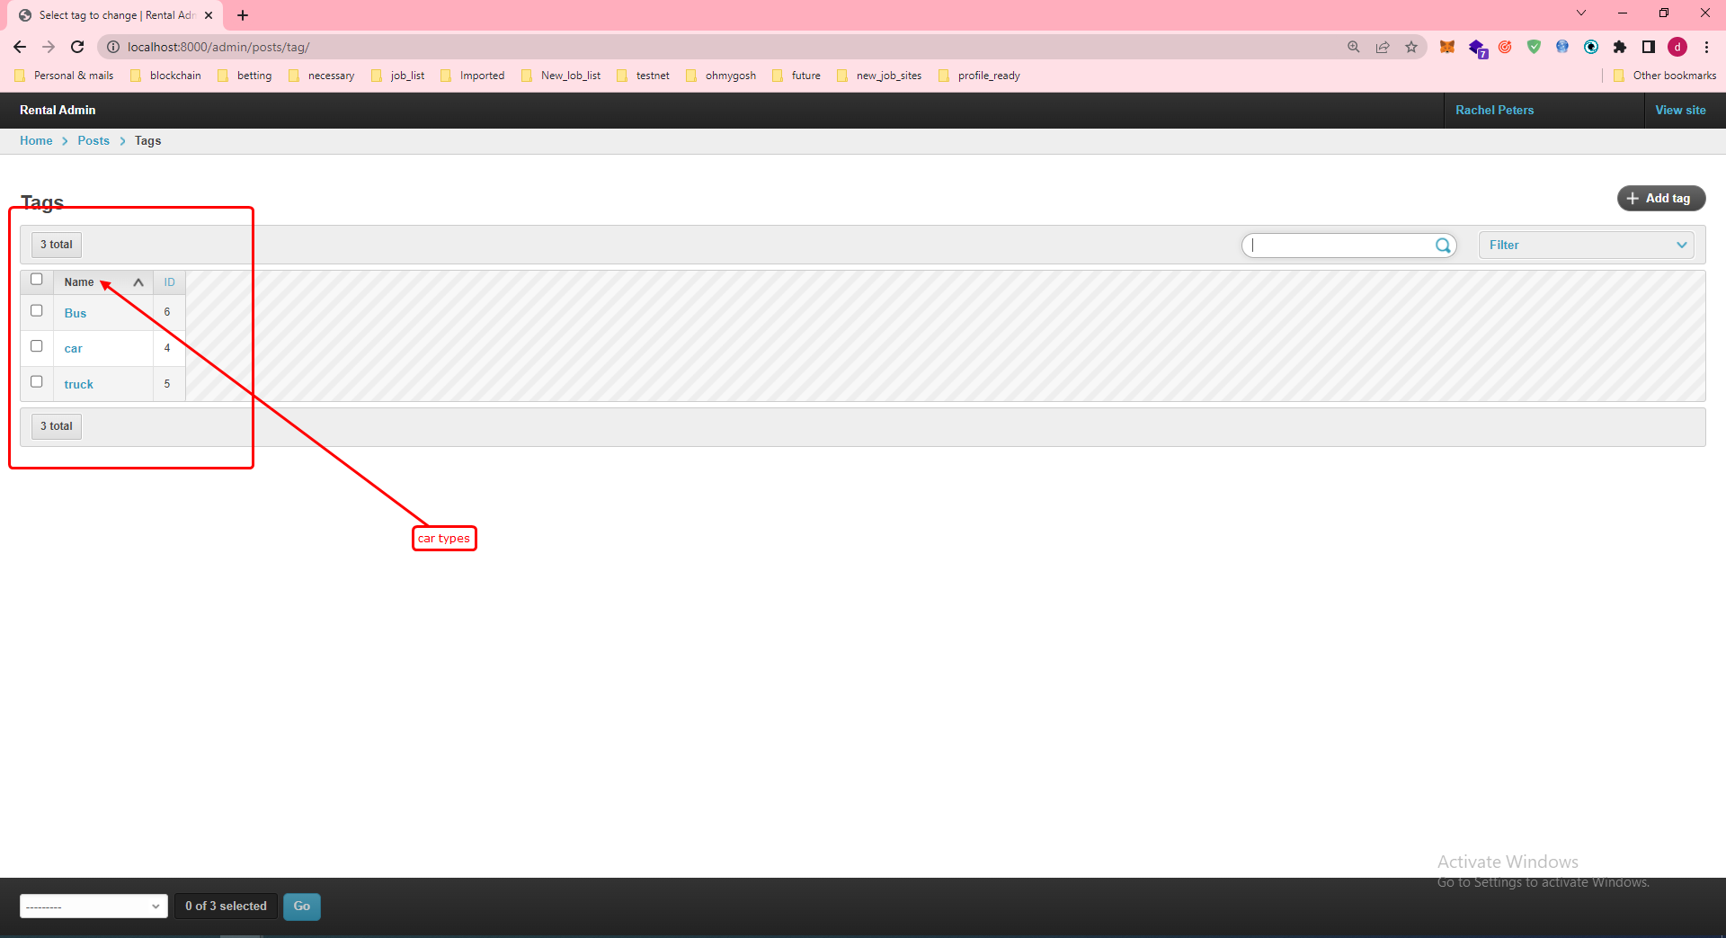

## 2-5 History_page

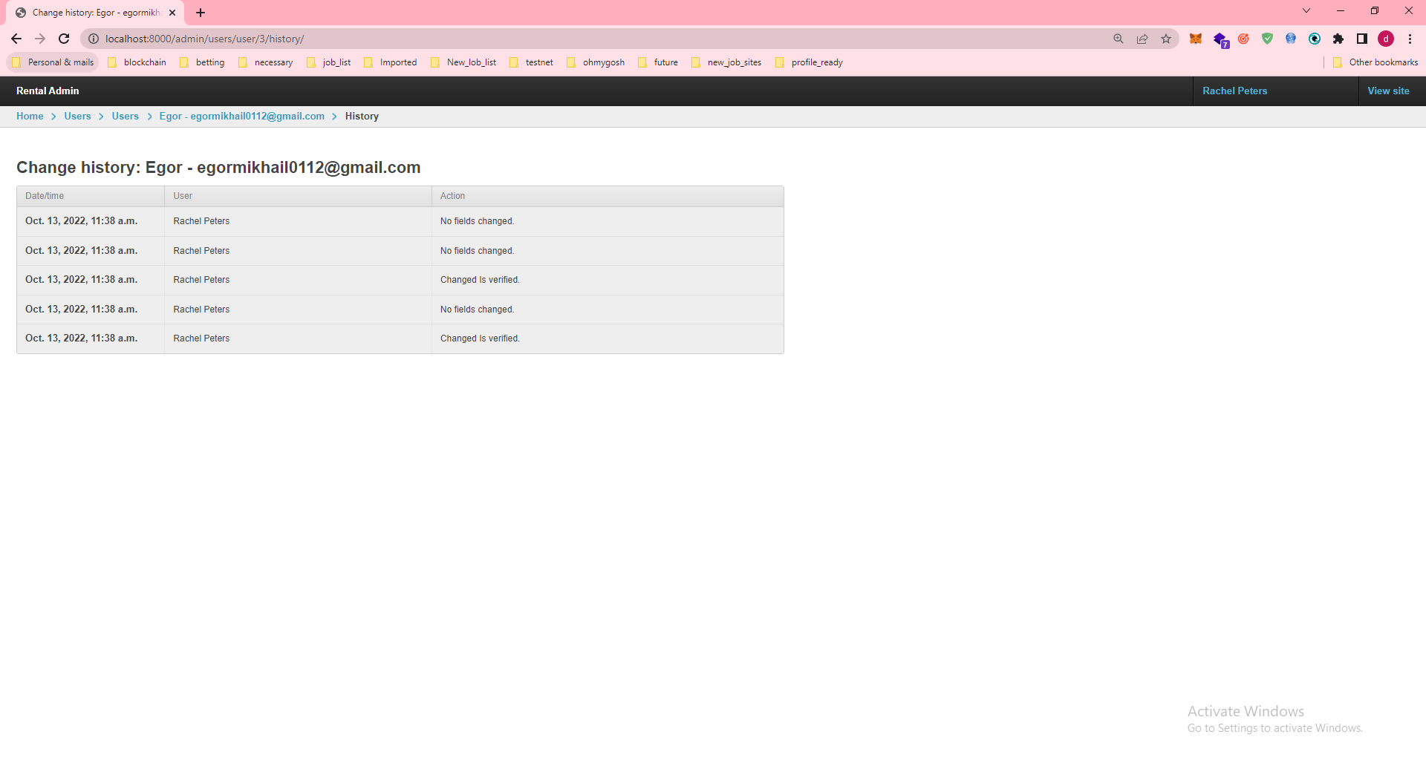

## 2-6 Token Inforamtion

